AD006 COSC 2534
Operating System Administration
Skills Exam 2

First Name: | Vu
Last Name: | Nguyen
Student ID: | s4010423

Pre-requisite
Task 1 :
You must have available two 2x Windows Server’s Machine and 1 Windows Client Operating Systems Virtual Machines with VirtualBox Guest Additions installed and turn firewalls off respectively.
Points to be noted for this skill test is as follows:
- Create the same three VMs with the same hardware specifications.
- Install Windows server 2019/2022 (Datacenter evaluation) for Server 1 and Server 2.
- Install windows 10/11 (Pro or enterprise) for the client.
- Use the password Rmit1234! For all the three VMs
- Use internal network Adaptor for all the three VMs with the same settings.
- Install Guest editions in all the three VMs.
- Turn off the windows firewall in all the three VMs.
- Configure the following IP setting for all the three VMs
Server1 IP: 192.168.80.30 Server2 IP: 192.168.80.60
Default Gateway 192.168.80.1 Default Gateway 192.168.80.1
Preferred DNS server: 192.168.80.30 Preferred DNS server: 192.168.80.30

Client IP: 192.168.80.90
Preferred DNS server: 192.168.80.30

Ping from Server1 to Server2 and Client.
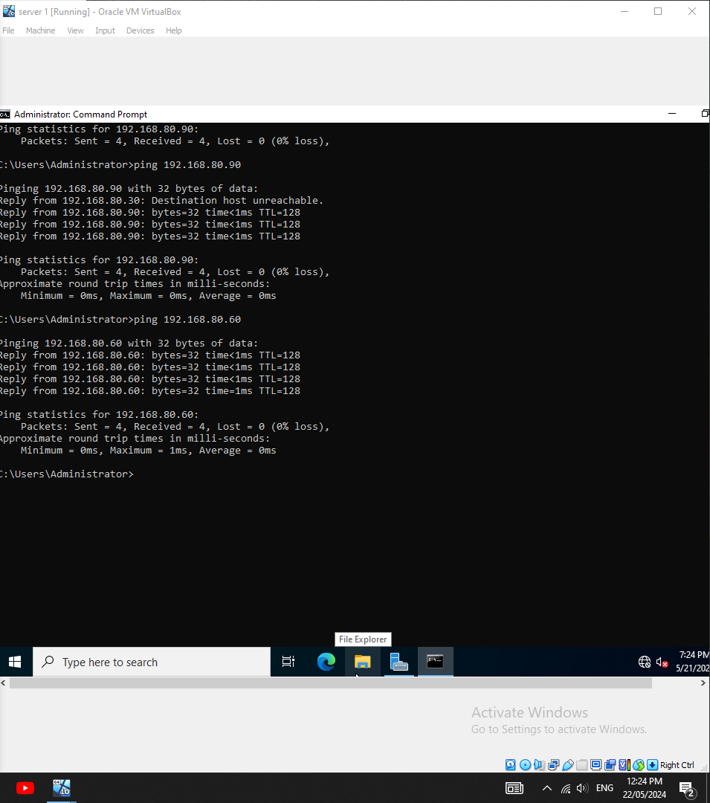
Ping from Server2 to Server1 and Client.
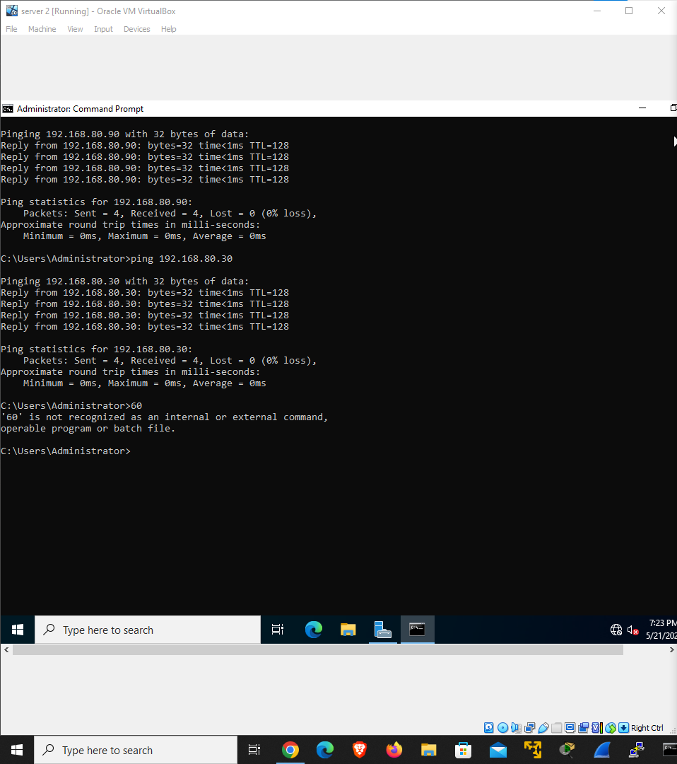
Ping from Client to Server1 and Server2.
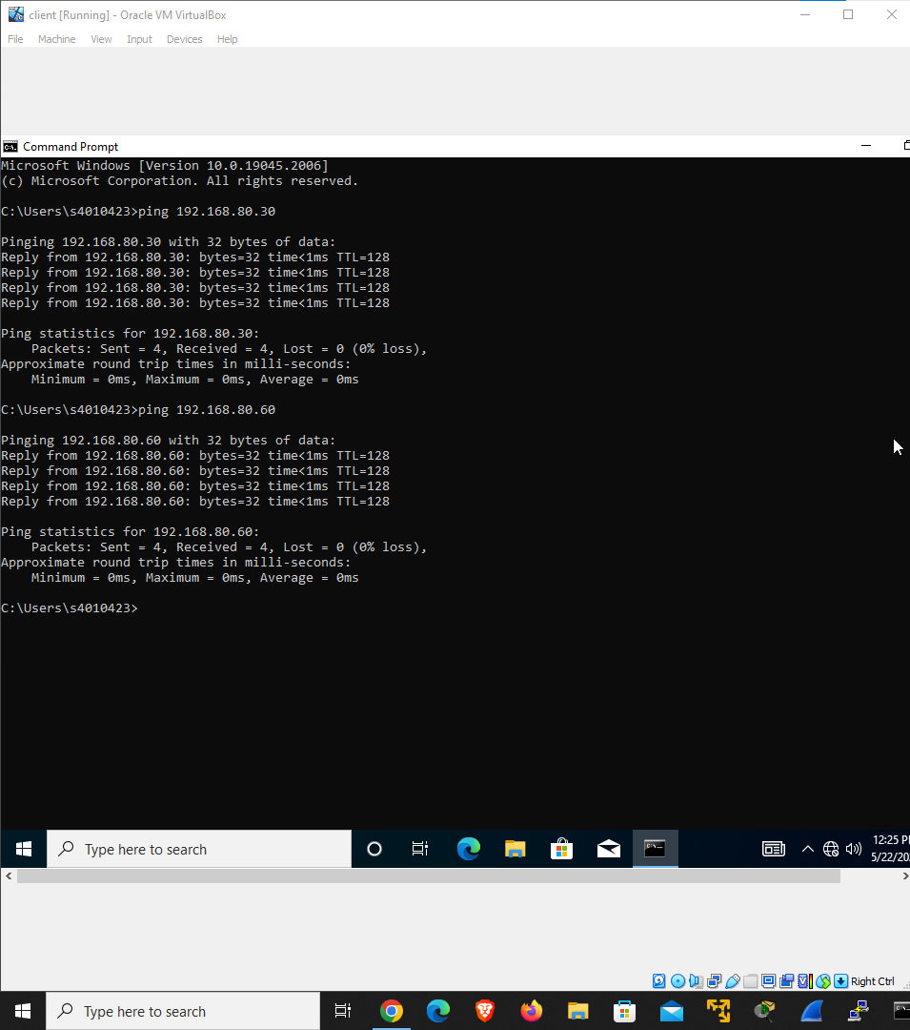
- Set the computer names of the Three VMs ( Win2019/2022primary , Win2019/2022secondary , win10/11client)
- Install ADDS and DNS at the same time in server 1
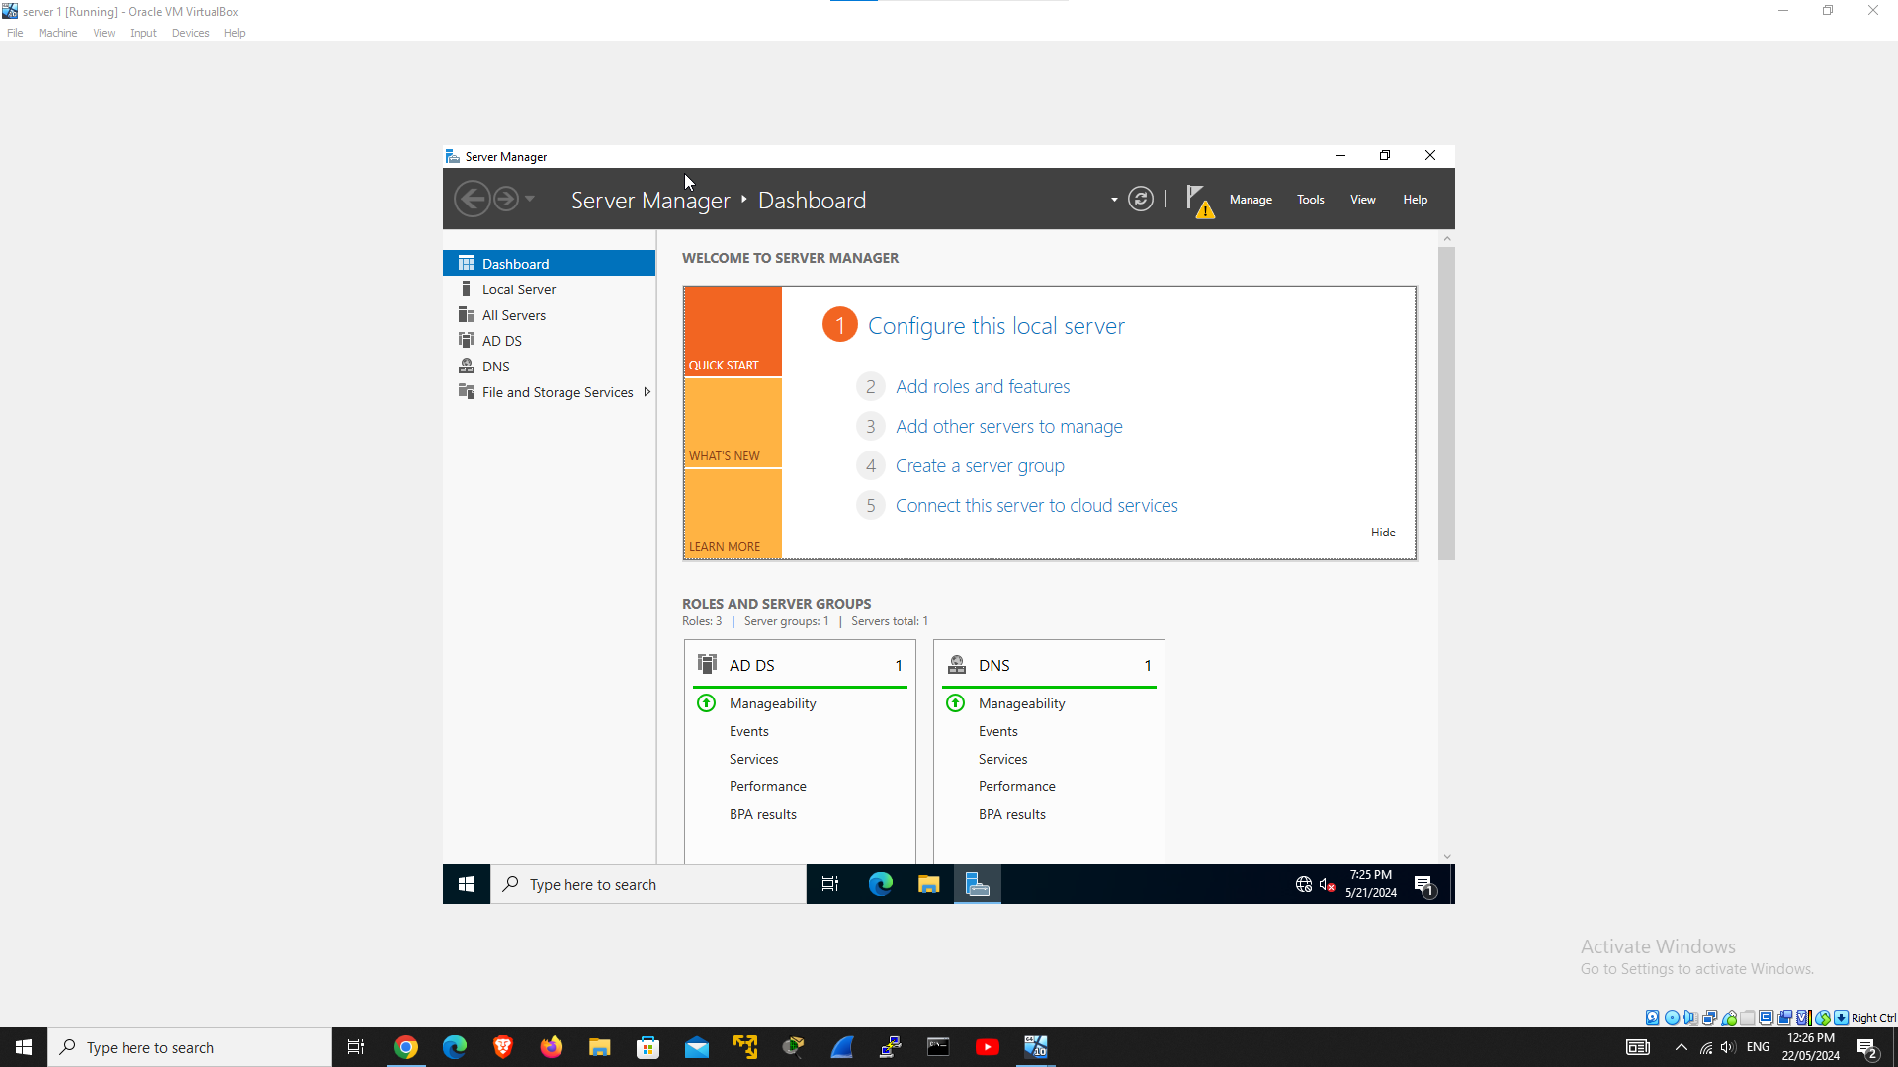
- Promoting Server1 to be Domain Controller with DNS and GC for the Domain named as SkillsCOSC2534.com
- Join server 2 to the Server 1 domain.
- 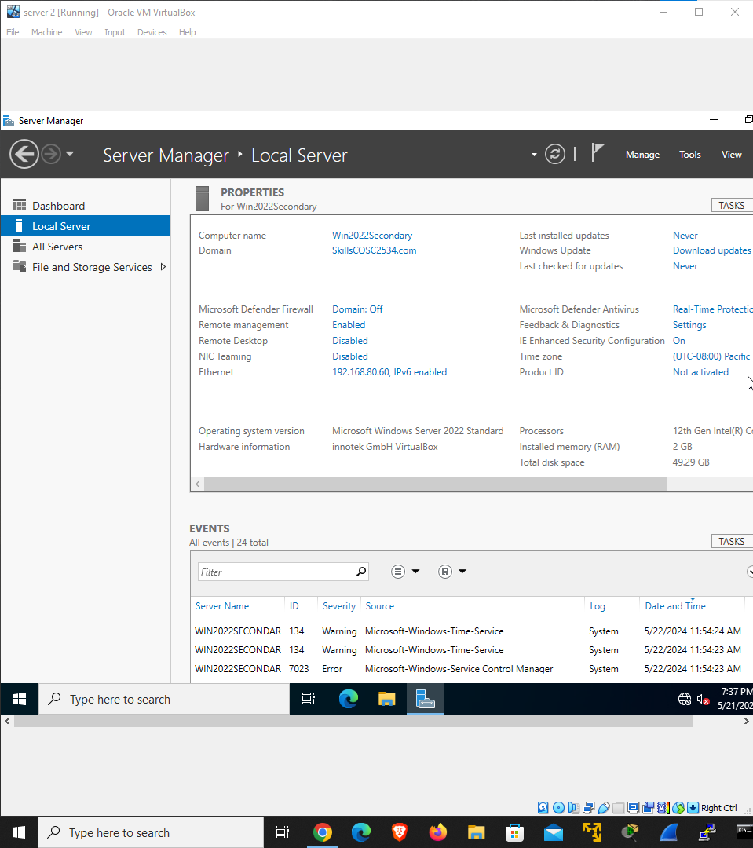
- Join Client VM to the server 1.
- 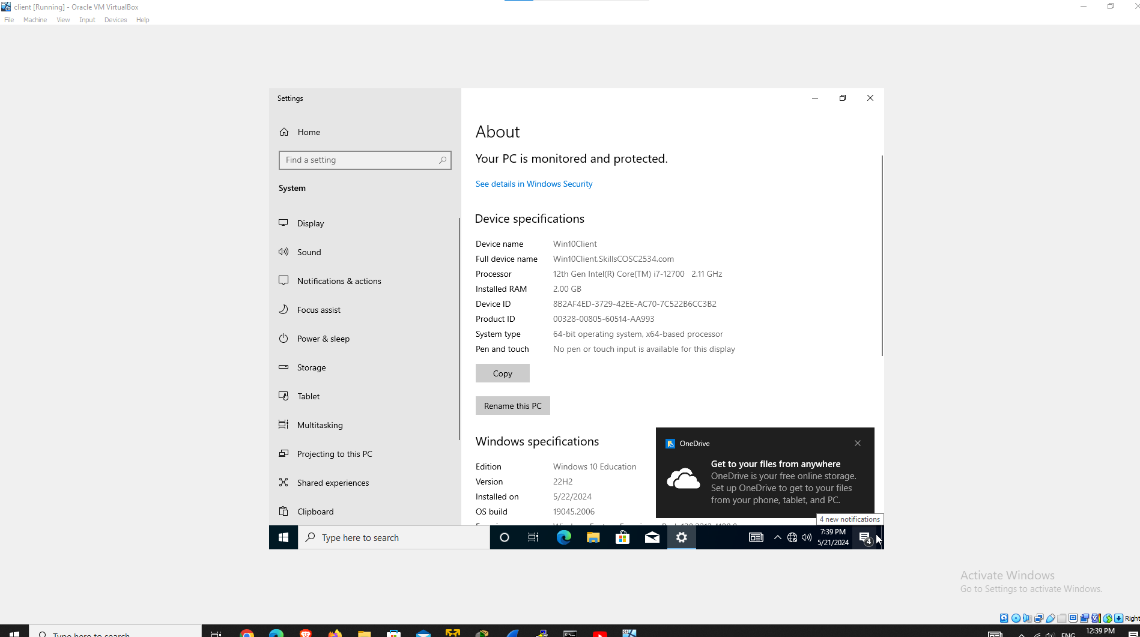

[Take Screenshots for completing the points above] -- 5 Marks

